­­A

Learning Project-Il Report

On

**“LANGUAGE TRANSLATOR”**

Submitted in partial fulfillment of

The requirements for the 4th Semester Sessional Examination of

BACHELOR OF TECHNOLOGY

IN

**COMPUTER SCIENCE & ENGINEERING**

By

**NAME**

**AMARNATH PANDA**

**SANCHITA SABAT**

**CHANDAN DANDIA**

**Registration No.**

**21UG010149**

**21UG010568**

**21UG010264**

**DEPARTMENT OF COMPUTER SCIENCE & ENGINEERINGS**

## C:\Users\pc\Pictures\BB02.png

GIET UNIVERSITY, Gunupur

**2022 - 23**

**GIET UNIVERSITY,GUNUPUR**

***Dist. - Rayagada, Odisha-765022,* *Contact:- +91 7735745535, 06857-250170,172, Visit us:-* www.giet.edu**

**Department of Computer Science & Engineering**

**CERTIFICATE**

**This is to certify that the project work entitled “LANGUAGE TRANSLATOR” is done by Name- Amarnath Panda , Sanchita Sabat , Chandan Dandia . Regd. No. -21UG010149 , 21UG010568 , 21UG010264 in partial fulfillment of the requirements for the 3rd Semester Sessional Examination of Bachelor of Technology in Computer Science and Engineering during the academic year 2022-23. This work is submitted to the department as a part of evaluation of 4th Semester Learning Project-II.**

Proctors Class Teacher

MR. GVS NARAYAN MR .SITANSHU KAR

Project Coordinator, 2nd Year HoD, CSE, 2nd Year

**Mr.Bhavani Sankar Panda**  **Dr. K.Murali Gopal**

ACKNOWLEDGEMENT

We would like to thank our proctors Mr. GVS Narayana for your invaluable support and guidance during our project.

Secondly we would like to thank our class teacher Mr.Sitanshu Kar for your guidance and feedback have been instrumental in shaping our ideas and helped us in achieving our project goals.

Thirdly we would like to thanks our Project Coordinator Mr.Bhavani Sankar Panda for your continued support and membership have been invaluable , and we are deeply grateful for your guidance.

A special gratitude to our HOD Dr. K.Murali Gopal and Dy. Dean, Computational Science Dr.Sanjay Kumar for your leadership and guidance have been invaluable in shaping our ideas and helping us realize our potential .

Thanks to friends and any others to whom you want.

Name and Regd.No of Students

Amarnath Panda (21UG010149)

Sanchita Sabat (21UG010568)

Chandan Dandia (21UG010264)

**ABSTRACT**

Language translation is an essential aspect of communication that allows individuals from different parts of the world to understand each other's ideas and cultures. With the advent of technology, language translators have become an indispensable tool for businesses, travelers, and researchers who need to interact with people from diverse backgrounds. This project aims to develop a language translator using HTML, CSS, and JavaScript.

The project will focus on the development of a web-based application that can translate text from one language to another. The project will utilize the Google Translate API to ensure accuracy and efficiency. The application will provide users with a user-friendly interface that allows them to input text in the source language and select the target language. The translated text will be displayed in real-time, allowing users to communicate more effectively with people who speak different languages.

The development of this project will require a good understanding of HTML, CSS, and JavaScript. HTML will be used to structure the web page and define the content, CSS will be used to style the web page and make it visually appealing, while JavaScript will be used to handle the translation process and provide a smooth user experience. The Google Translate API will be integrated with the project to ensure accuracy and efficiency.

One of the main challenges of developing a language translator is ensuring accuracy and consistency in the translation process. The Google Translate API utilizes machine learning algorithms to provide accurate translations, but it still requires human oversight to ensure quality. The project will also focus on optimizing the performance of the application to ensure it can handle a high volume of translation requests.

In conclusion, this project aims to develop a language translator using HTML, CSS, and JavaScript. The project will utilize the Google Translate API to ensure accuracy and efficiency, and it will provide users with a user-friendly interface for easy input and output of translated text. The development of this project will require a good understanding of HTML, CSS, and JavaScript, as well as a commitment to ensuring the accuracy and consistency of the translation process.

**INTRODUCTION**

**PURPOSE**

The purpose of a language translator is to convert text or speech from one language to another. Language translators play a crucial role in enabling communication between people who speak different languages, facilitating trade, diplomacy, education, research, and cultural exchange. With globalization and the increasing interconnectedness of the world, language translators have become an essential tool for individuals and businesses operating in international markets.

The primary purpose of language translators is to break down language barriers and promote understanding between people from diverse linguistic and cultural backgrounds. Language translators allow people to communicate more effectively, exchange ideas, and build relationships that transcend language differences. They also enable access to information and resources that would otherwise be inaccessible to individuals who do not speak the language.

Language translators are used in a wide range of contexts, including travel, business, education, research, and government. They are used to translate documents, websites, social media content, and other forms of written and spoken communication. They are also used in real-time communication, such as interpreting services for conferences, meetings, and interviews.

Overall, the purpose of language translators is to facilitate effective communication and promote cross-cultural understanding, making the world a more connected and inclusive place.

**PROJECT SCOPE**

The scope of language translator is vast and continues to expand with the increasing globalization of the world. The scope of language translator can be seen in various fields such as business, education, tourism, research, and government. Here are some examples of the scope of language translator:

1. Business: Language translators are essential for businesses that operate in international markets. They help businesses to communicate with clients, partners, and customers from different linguistic backgrounds. With the help of language translators, businesses can translate their websites, product descriptions, marketing materials, and contracts into multiple languages, making their products and services more accessible to a broader audience.

2. Education: Language translators are used in education to help students who speak different languages to communicate and learn. They are used to translate textbooks, educational materials, and lectures into the students' native language, making education more accessible and inclusive. Language translators are also used to teach foreign languages and to facilitate exchange programs between schools in different countries.

3. Tourism: Language translators are essential in the tourism industry, enabling tourists to communicate with locals and navigate unfamiliar environments. They are used in hotels, restaurants, and tourist attractions to provide information in multiple languages, making it easier for tourists to enjoy their travel experiences.

4. Research: Language translators are used in research to enable researchers to access information from different languages and cultures. They are used to translate academic papers, reports, and other research materials, enabling researchers to collaborate across borders and contribute to the advancement of knowledge in their fields.

5. Government: Language translators are used in government to promote cross-cultural understanding and communication. They are used in international diplomacy, enabling officials to communicate with their counterparts from different countries. They are also used to translate laws, policies, and other government documents, making them accessible to citizens who speak different languages.

In conclusion, the scope of language translator is vast, encompassing various fields that require effective cross-cultural communication. With the increasing globalization of the world, the demand for language translators is expected to continue growing, making it an exciting and rewarding career path.

**PRODUCT FEATURES**

Language translators offer a wide range of features that help users to communicate more effectively and accurately across different languages. Here are some of the key features of language translators:

1. Translation of Text and Speech: Language translators can translate both written and spoken communication from one language to another. They can translate text from documents, web pages, and other sources, as well as speech from phone calls, meetings, and interviews.

2. Multiple Language Support: Language translators can support multiple languages, allowing users to translate between different language pairs. They can translate between popular languages such as English, Spanish, French, German, and Chinese, as well as less commonly spoken languages.

3. Real-time Translation: Many language translators offer real-time translation, enabling users to communicate with people from different language backgrounds in real-time. This is especially useful for video conferencing, phone calls, and other forms of real-time communication.

4. Customizable Settings: Language translators often offer customizable settings that allow users to adjust the translation output to suit theirpreferences.

**Works done in the related area**

The work done in related areas of language translator can be broadly categorized into the following fields:

1. Artificial Intelligence: Artificial intelligence (AI) plays a crucial role in language translator technology. Researchers are constantly working on developing new algorithms and models that can improve the accuracy and speed of language translation. Deep learning models such as neural networks are used to train language translator systems on large amounts of data, enabling them to learn to translate with higher accuracy.

2. Natural Language Processing: Natural language processing (NLP) is a subfield of AI that focuses on enabling computers to understand and interpret human language. Researchers in this field work on developing algorithms and models that can analyze text and speech, identify patterns, and extract meaning from language data. NLP techniques are used to enhance the accuracy and speed of language translators.

3. Machine Learning: Machine learning (ML) is a field of study that focuses on enabling machines to learn and improve their performance without being explicitly programmed. Researchers in this field work on developing algorithms that can analyze language data and improve the accuracy of language translators. Techniques such as supervised learning, unsupervised learning, and reinforcement learning are used to train language translator systems.

4. Linguistics: Linguistics is the scientific study of language and its structure, including the study of grammar, syntax, and semantics. Researchers in this field work on developing theories and models that can help to improve the accuracy of language translators. They also work on developing language resources such as dictionaries and corpora that can be used to train language translator systems.

Overall, the work done in related areas of language translator involves interdisciplinary research and development in fields such as AI, NLP, ML, and linguistics. This work aims to improve the accuracy and speed of language translators and enable more effective communication between people who speak different languages.

**SYSTEM ANALYSIS**

**SOFTWARE REQIREMENT**

Here's an example of software requirements using HTML, CSS, and JavaScript:

1. HTML: The language translator software would require a web page written in HTML to provide a user interface for inputting text or speech to be translated and displaying the translated output. The HTML page should be designed to be responsive and accessible across different devices.

2. CSS: CSS would be used to style the HTML page and create an appealing and user-friendly interface. The CSS should be optimized for performance and compatibility with different browsers.

3. JavaScript: JavaScript would be used to implement the translation engine and provide interactivity to the web page. The translation engine could be based on a pre-trained machine learning model or statistical models for translation. JavaScript would also be used to handle user input and process the output.

4. APIs: APIs such as Google Translate or Microsoft Translator could be integrated with the JavaScript code to provide access to translation services. These APIs would require an API key for authentication and would be used to translate the input text or speech.

5. User Input: The HTML and JavaScript code would require a user input field for entering text or speech to be translated. The user input field would need to be designed to handle various types of input, such as voice input or keyboard input.

6. Output Display: The HTML and JavaScript code would require a display area for displaying the translated output. The output display area should be designed to handle different types of output, such as text, images, or audio.

Overall, the software requirements for a language translator using HTML, CSS, and JavaScript would require expertise in web development and JavaScript programming. The software would need to be constantly updated and improved to keep up with changes in language usage and advances in technology.­­­

# **FLOW CHART**

Yes, it is possible to make a flow chart of a language translator using HTML, JS, and CSS. Here is an example of a high-level flow chart for a web-based language translator:

1. User Inputs Text or Speech to be Translated

- User inputs text into an HTML form input or submits an audio file to be transcribed

2. Preprocessing:

- Text input is tokenized and cleaned using JavaScript functions

- Audio input is transcribed using a web-based transcription API

3. Translation Engine:

- Translated output is generated using a web-based translation API or JavaScript functions

- Translation memory or other resources may be used to improve accuracy

4. Postprocessing:

- Output text is filtered and cleaned using JavaScript functions

- Additional JavaScript functions are applied to improve fluency and accuracy

5. Output:

- Translated text is displayed in the HTML document using CSS styling

- Output may be displayed in various formats, such as text, audio, or images

6. Feedback:

- User feedback on the translation quality may be collected using JavaScript functions or web-based forms

Note that this flow chart is a simplified representation of a web-based language translator and may vary depending on the specific implementation and features of the software.

Input text

Feedback

Output

Post Processing

Translation Engine

Preprocessing

**Principle used in language translation**

The principle used in language translation involves the use of algorithms and machine learning models to convert text or speech from one language to another. There are two main approaches to language translation: rule-based and statistical/machine learning-based.

In rule-based translation, a set of rules are created by linguists and programmers to translate text from one language to another. These rules are based on the grammatical structure and vocabulary of both languages and are used to identify the corresponding words and phrases in the target language. Rule-based translation can be accurate but is limited by the number of rules that can be created, and it can be difficult to account for the nuances and irregularities of natural language.

In statistical/machine learning-based translation, algorithms are trained on large amounts of data to learn the patterns and relationships between words and phrases in both languages. These models use statistical techniques to determine the most likely translation based on the context of the input text. As the models are trained on more data, they can become increasingly accurate in their translations.

Both approaches to language translation involve the use of sophisticated software and require significant computational resources. Additionally, the accuracy of the translation depends on the quality and quantity of the training data, as well as the complexity of the languages being translated. The best language translators use a combination of rule-based and statistical/machine learning-based techniques to achieve the highest level of accuracy and fluency in their translations.

## ****Artificial intelligence and language translation****

Nowadays, it’s becoming easier for international businesses to overcome language barriers. AI now takes care of complicated tasks that were once the sole responsibility of human linguists. Machine learning, a specific type of AI, now makes it possible for computers to make more informed decisions and apply self-learning principles to these decisions.

**AI machines** are used across many industries, including the financial sector for forecasting and the retail sector for sales and marketing purposes. AI and machine learning provide previously unavailable insights, handling queries in just about any language simultaneously.

Advancements in machine learning also make it possible for AI to offer more refined responses to a search query. Examples of language barriers that once caused an issue for search include non-native English speakers using misspelled terms. Nowadays, AI is incredibly proficient at recognizing intent and context. In other words, a misspelled search term isn’t going to stop a user from getting to where they need to be.

## ****What is natural language processing?****

A key element of AI and machine learning is **natural language processing (**[NLP](https://www.getblend.com/blog/localization-glossary/)**)**. In short, it allows translation machines to more accurately comprehend languages. It’s thanks to NLP that machine translation is possible. It can carry out simple tasks like proofing translated texts for spelling and grammatical errors. It can also understand some of the nuances of human languages, such as sentiment and emotive meaning.

NLP uses advanced algorithms to not only [translate raw text](https://www.getblend.com/online-translation/transcription-services/) but also predict purpose and intent. It can provide suggestions and insights, along with basic text-to-text translations.

Currently, human linguists still need to **refine translations delivered by NLP**, but it’s a fast-evolving field that can already help automate the [fast translation](https://www.getblend.com/online-translation/) process.

**ROLE OF NEURAL NETWORK**

Neural networks play a critical role in modern language translators. Neural networks are a type of machine learning algorithm that are inspired by the structure and function of the human brain. They are particularly effective in natural language processing tasks like language translation because they can learn to recognize patterns and relationships between words and phrases in large amounts of data.

In a language translator that uses neural networks, the input text is first preprocessed to convert it into a numerical format that can be processed by the network. The numerical data is then fed into the network, which consists of multiple layers of interconnected nodes that perform computations on the input data. The network uses a process called backpropagation to adjust the weights of the connections between the nodes to minimize the difference between the predicted output and the actual output.

Neural networks can be used to model complex relationships between words and phrases in both the source and target languages. They can also learn to capture the nuances of language and translate idiomatic expressions and colloquialisms more accurately than rule-based systems. By training on large amounts of data, neural network-based language translators can achieve high levels of accuracy and fluency in their translations.

Overall, neural networks play a crucial role in modern language translators by enabling them to learn from large amounts of data and accurately model the complex relationships between words and phrases in multiple languages**.**

**ROLE OF MACHINE LEARNING**

Machine learning plays a crucial role in language translators by enabling them to improve their accuracy and fluency over time. Machine learning algorithms allow language translators to automatically learn from the vast amounts of data that are available on the internet and in other sources.

One way that machine learning is used in language translation is through the development of statistical machine translation (SMT) models. SMT models use large amounts of bilingual texts to learn how to translate words and phrases from one language to another. The models learn from the data and are able to identify patterns and relationships between words and phrases, which they can then use to make accurate translations.

Another way that machine learning is used in language translators is through the development of neural machine translation (NMT) models. NMT models use artificial neural networks to learn the relationships between words and phrases in both the source and target languages. By training on large amounts of data, NMT models can capture the nuances of language and translate idiomatic expressions and colloquialisms more accurately than SMT models.

Machine learning is also used to improve the user experience of language translators. For example, machine learning algorithms can be used to suggest translations as the user types, or to automatically correct errors in the translated text.

Overall, machine learning plays a critical role in language translators by enabling them to learn from data and improve their accuracy and fluency over time. Machine learning algorithms are essential for developing more sophisticated and effective language translation systems that can meet the needs of users around the world.

**ROLE OF ARTIFICIAL INTELLIGENCE (AI)**

Artificial Intelligence (AI) plays a crucial role in language translators by enabling them to perform complex tasks that would be difficult or impossible for humans to do on their own. AI algorithms can be used to analyze and process vast amounts of data, recognize patterns and relationships between words and phrases, and make accurate translations in real-time.

One way that AI is used in language translators is through the development of machine learning models, such as the neural machine translation (NMT) models mentioned earlier. These models use AI algorithms to learn from large amounts of data and improve their accuracy and fluency over time.

AI is also used in language translators to improve the user experience. For example, AI algorithms can be used to suggest alternative translations, provide contextually relevant translations based on the user's location or browsing history, or generate spoken translations in real-time.

Additionally, AI can be used to develop more sophisticated language translators that can handle more complex tasks. For example, AI algorithms can be used to recognize and translate handwritten text or speech, or to automatically identify and translate technical jargon or industry-specific terminology.

Overall, AI plays a critical role in language translators by enabling them to learn from data, improve their accuracy and fluency, and perform more complex tasks. As AI technology continues to advance, we can expect to see more sophisticated and effective language translation systems that can meet the needs of users around the world.

**PSEUDO CODE**

**HTML**

<html lang="en">

<head>

<meta charset="UTF-8">

<meta http-equiv="X-UA-Compatible" content="IE=edge">

<meta name="viewport" content="width=device-width, initial-scale=1.0">

<title>A Language Translator</title>

<link rel="stylesheet" href="script.css">

</head>

<body>

<div class="container">

<div class="wrapper">

<div class="text-input">

<textarea spellcheck="false" class="from-text" placeholder="Enter text"></textarea>

<ul class="controls">

<li class="row from">

<div class="icons">

<ion-icon id="from" name="volume-medium-outline"></ion-icon>

<ion-icon id="from" name="copy-outline"></ion-icon>

</div>

<select></select>

</li>

<li class="exchange">

<ion-icon name="swap-vertical"></ion-icon>

<li class="row to">

<select></select>

<div class="icons">

<ion-icon id="to" name="volume-medium-outline"></ion-icon>

<ion-icon id="to" name="copy-outline"></ion-icon>

</div>

</li>

</ul>

<textarea spellcheck="false" readonly disabled class="to-text" placeholder="Translation"></textarea>

</div>

</div>

<button>Translate it</button>

</div>

<Script Src="script.Js"></Script>

</body>

</html>

**CSS**

* {

padding: 0;

margin: 0;

box-sizing: border-box;

font-family: "Poppins", Lalezar, cursive, sans-serif;

}

body {

display: flex;

align-items: center;

justify-content: center;

padding: 0 10px;

min-height: 100vh;

background: #6320ee;

}

.container {

max-width: 700px;

width: 100%;

padding: 30px;

background: #fff;

border-radius: 1rem;

box-shadow: 0px 0px 36px -5px #b8b8ff;

}

.wrapper {

border-radius: 5px;

border: 1px solid #ccc;

}

.wrapper .text-input {

display: block;

}

.text-input .to-text {

border-radius: 0px;

border-top: 1px solid #ccc;

}

.text-input textarea {

height: 250px;

width: 100%;

border: none;

outline: none;

resize: none;

background: none;

font-size: 18px;

padding: 10px 15px;

border-radius: 0.3rem;

}

.text-input textarea::placeholder {

color: #b7b6b6;

}

.controls,

li,

.icons,

.icons ion-icon {

display: flex;

align-items: center;

justify-content: space-between;

}

.controls {

list-style: none;

padding: 12px 15px;

border-top: 1px solid #ccc;

}

.controls .row .icons {

width: 38%;

}

.controls .row .icons ion-icon {

width: 50px;

color: #adadad;

font-size: 1.7rem;

cursor: pointer;

transition: transform 0.2s ease;

justify-content: center;

}

.controls .row.from .icons {

padding-right: 15px;

border-right: 1px solid #ccc;

}

.controls .row.to .icons {

padding-left: 15px;

border-left: 1px solid #ccc;

}

.controls .row select {

color: #333;

border: none;

outline: none;

font-size: 18px;

background: none;

padding-left: 5px;

}

.text-input textarea::-webkit-scrollbar {

width: 4px;

}

.controls .row select::-webkit-scrollbar {

width: 8px;

}

.text-input textarea::-webkit-scrollbar-track,

.controls .row select::-webkit-scrollbar-track {

background: #fff;

}

.text-input textarea::-webkit-scrollbar-thumb {

background: #ddd;

border-radius: 8px;

}

.controls .row select::-webkit-scrollbar-thumb {

background: #999;

border-radius: 8px;

border-right: 2px solid #ffffff;

}

.controls .exchange {

color: #adadad;

cursor: pointer;

font-size: 1.7rem;

transition: transform 0.2s ease;

}

.controls ion-icon:active {

transform: scale(0.9);

}

.container button {

width: 100%;

padding: 14px;

outline: none;

border: none;

color: #fff;

cursor: pointer;

margin-top: 20px;

font-size: 1.2rem;

border-radius: 0.3rem;

background: #6320ee;

}

@media (max-width: 660px) {

.container {

padding: 20px;

}

.wrapper .text-input {

flex-direction: column;

}

.text-input .to-text {

border-left: 0px;

border-top: 1px solid #ccc;

}

.text-input textarea {

height: 200px;

}

.controls .row .icons {

display: inline-flex;

flex-direction: column;

}

.container button {

padding: 13px;

font-size: 1.2rem;

}

.controls .row select {

font-size: 1.2rem;

}

.controls .exchange {

font-size: 1.2rem;

}

}

@media screen and (max-width: 1250px) {

.container {

zoom: 0.7;

}

}

**JAVA SCRIPT**

const languages = {

"am-ET": "Amharic",

"ar-SA": "Arabic",

"be-BY": "Bielarus",

"bem-ZM": "Bemba",

"bi-VU": "Bislama",

"bjs-BB": "Bajan",

"bn-IN": "Bengali",

"bo-CN": "Tibetan",

"br-FR": "Breton",

"bs-BA": "Bosnian",

"ca-ES": "Catalan",

"cop-EG": "Coptic",

"cs-CZ": "Czech",

"cy-GB": "Welsh",

"da-DK": "Danish",

"dz-BT": "Dzongkha",

"de-DE": "German",

"dv-MV": "Maldivian",

"el-GR": "Greek",

"en-GB": "English",

"es-ES": "Spanish",

"et-EE": "Estonian",

"eu-ES": "Basque",

"fa-IR": "Persian",

"fi-FI": "Finnish",

"fn-FNG": "Fanagalo",

"fo-FO": "Faroese",

"fr-FR": "French",

"gl-ES": "Galician",

"gu-IN": "Gujarati",

"ha-NE": "Hausa",

"he-IL": "Hebrew",

"hi-IN": "Hindi",

"hr-HR": "Croatian",

"hu-HU": "Hungarian",

"id-ID": "Indonesian",

"is-IS": "Icelandic",

"it-IT": "Italian",

"ja-JP": "Japanese",

"kk-KZ": "Kazakh",

"km-KM": "Khmer",

"kn-IN": "Kannada",

"ko-KR": "Korean",

"ku-TR": "Kurdish",

"ky-KG": "Kyrgyz",

"la-VA": "Latin",

"lo-LA": "Lao",

"lv-LV": "Latvian",

"men-SL": "Mende",

"mg-MG": "Malagasy",

"mi-NZ": "Maori",

"ms-MY": "Malay",

"mt-MT": "Maltese",

"my-MM": "Burmese",

"ne-NP": "Nepali",

"niu-NU": "Niuean",

"nl-NL": "Dutch",

"no-NO": "Norwegian",

"ny-MW": "Nyanja",

"ur-PK": "Pakistani",

"pau-PW": "Palauan",

"pa-IN": "Panjabi",

"ps-PK": "Pashto",

"pis-SB": "Pijin",

"pl-PL": "Polish",

"pt-PT": "Portuguese",

"rn-BI": "Kirundi",

"ro-RO": "Romanian",

"ru-RU": "Russian",

"sg-CF": "Sango",

"si-LK": "Sinhala",

"sk-SK": "Slovak",

"sm-WS": "Samoan",

"sn-ZW": "Shona",

"so-SO": "Somali",

"sq-AL": "Albanian",

"sr-RS": "Serbian",

"sv-SE": "Swedish",

"sw-SZ": "Swahili",

"ta-LK": "Tamil",

"te-IN": "Telugu",

"tet-TL": "Tetum",

"tg-TJ": "Tajik",

"th-TH": "Thai",

"ti-TI": "Tigrinya",

"tk-TM": "Turkmen",

"tl-PH": "Tagalog",

"tn-BW": "Tswana",

"to-TO": "Tongan",

"tr-TR": "Turkish",

"uk-UA": "Ukrainian",

"uz-UZ": "Uzbek",

"vi-VN": "Vietnamese",

"wo-SN": "Wolof",

"xh-ZA": "Xhosa",

"yi-YD": "Yiddish",

"zu-ZA": "Zulu"

};

const fromText = document.querySelector(".from-text"),

toText = document.querySelector(".to-text"),

exchageIcon = document.querySelector(".exchange"),

selectTag = document.querySelectorAll("select"),

icons = document.querySelectorAll(".row ion-icon");

(translateBtn = document.querySelector("button")),

selectTag.forEach((tag, id) => {

for (let lang_code in languages) {

let selected =

id == 0

? lang_code == "en-GB"

? "selected"

: ""

: lang_code == "fa-IR"

? "selected"

: "";

let option = `<option ${selected} value="${lang_code}">${languages[lang_code]}</option>`;

tag.insertAdjacentHTML("beforeend", option);

}

});

fromText.addEventListener("keyup", () => {

if (!fromText.value) {

toText.value = "";

}

});

translateBtn.addEventListener("click", () => {

let text = fromText.value.trim(),

translateFrom = selectTag[0].value,

translateTo = selectTag[1].value;

if (!text) return;

toText.setAttribute("placeholder", "Translating...");

let apiUrl = `https://api.mymemory.translated.net/get?q=${text}&langpair=${translateFrom}|${translateTo}`;

fetch(apiUrl)

.then((res) => res.json())

.then((data) => {

toText.value = data.responseData.translatedText;

data.matches.forEach((data) => {

if (data.id === 0) {

toText.value = data.translation;

}

});

toText.setAttribute("placeholder", "Translation");

});

});

exchageIcon.addEventListener("click", () => {

let tempText = fromText.value,

tempLang = selectTag[0].value;

fromText.value = toText.value;

toText.value = tempText;

selectTag[0].value = selectTag[1].value;

selectTag[1].value = tempLang;

});

icons.forEach((icon) => {

icon.addEventListener("click", ({ target }) => {

if (!fromText.value || !toText.value) return;

if (target.getAttribute("name") == "copy-outline") {

if (target.id == "from") {

navigator.clipboard.writeText(fromText.value);

} else {

navigator.clipboard.writeText(toText.value);

}

} else {

let utterance;

if (target.id == "from") {

utterance = new SpeechSynthesisUtterance(fromText.value);

utterance.lang = selectTag[0].value;

} else {

utterance = new SpeechSynthesisUtterance(toText.value);

utterance.lang = selectTag[1].value;

}

speechSynthesis.speak(utterance);

}

});

});

**CONCLUSION & LIMITATIONS**

**Conclusion:**

A language translator is a software or tool that is designed to convert text or speech from one language into another. It has made communication easier between people who speak different languages. Language translators have become increasingly popular and advanced, with machine learning and artificial intelligence playing a significant role in their development. They are used in a wide range of applications, including business, education, and travel.

**Limitations:**

While language translators have come a long way in recent years, they still have some limitations. Here are a few of them:

1. Accuracy: Language translators may not always provide accurate translations, especially when dealing with complex sentences or idiomatic expressions. This is because languages have unique grammar rules and structures that can be difficult to translate accurately.

2. Context: Language translators may not always consider the context of the text being translated. This can lead to errors or mistranslations that can change the meaning of the original text.

3. Regional Differences: Some languages have regional variations that can be difficult for language translators to account for. For example, Spanish spoken in Spain is different from Spanish spoken in Latin America.

4. Cultural Nuances: Languages have cultural nuances that can be difficult to translate accurately. For example, certain words or phrases may have different meanings in different cultures.

5. Slang and Jargon: Language translators may not be able to translate slang or jargon accurately, as these terms may not be commonly used in other languages.

**SCREEN-SHOTS**

1. EMPTY TEXT BOX

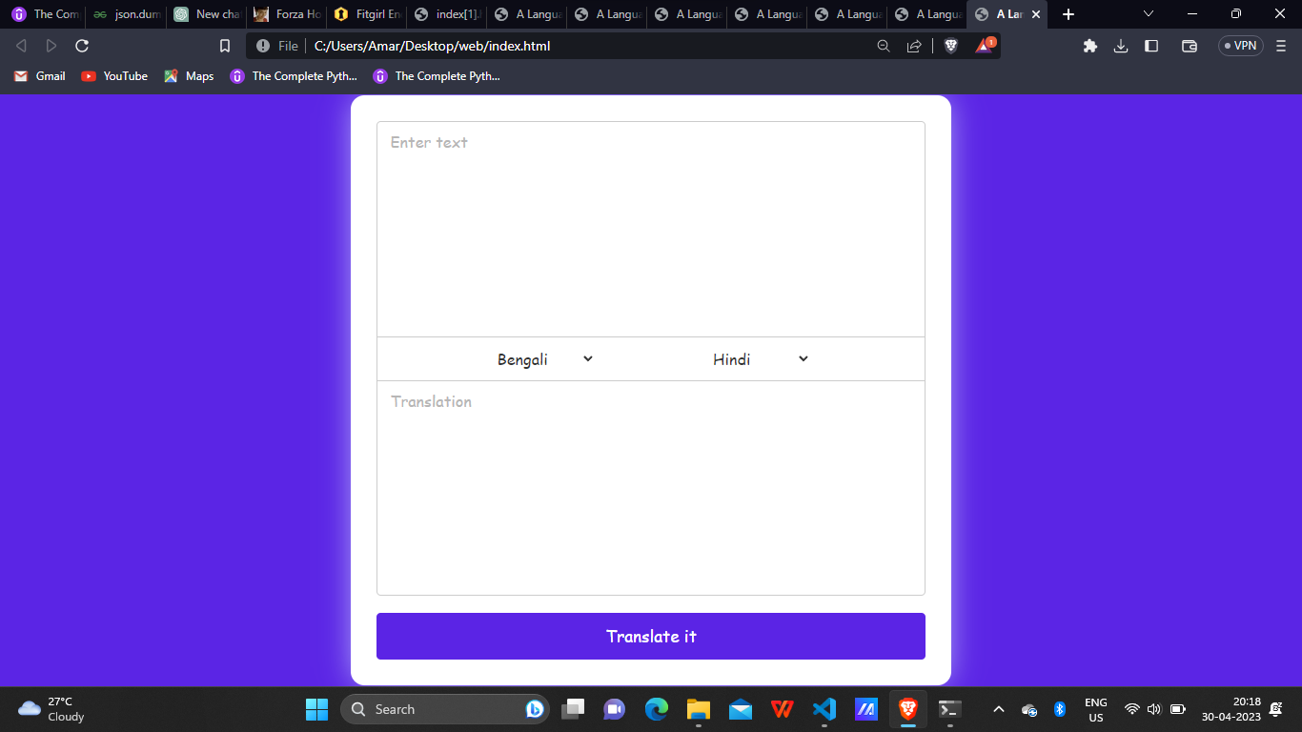

2 ENGLISH TO HINDI

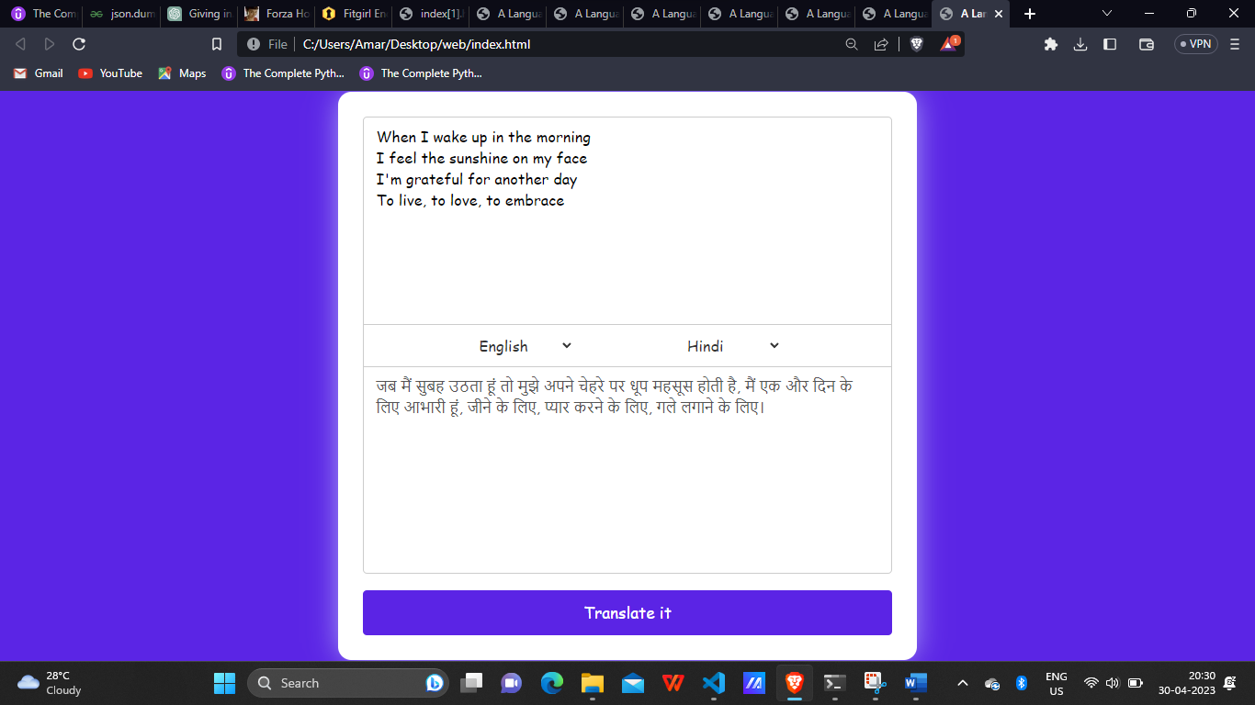

3.GERMAN TO HINDI

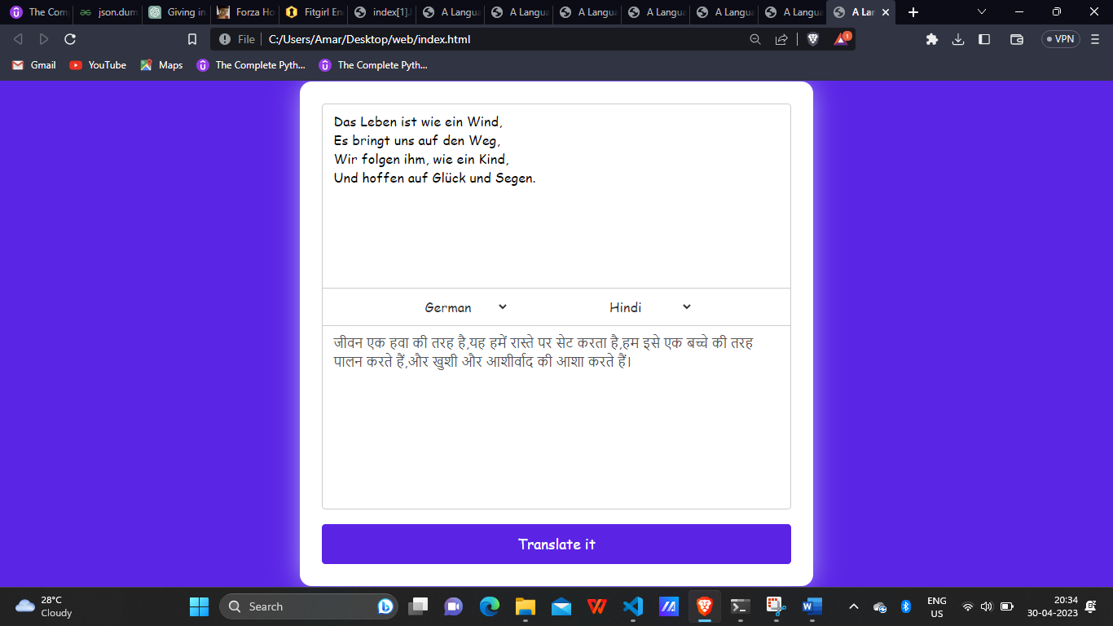

4.HINDI TO HINDI

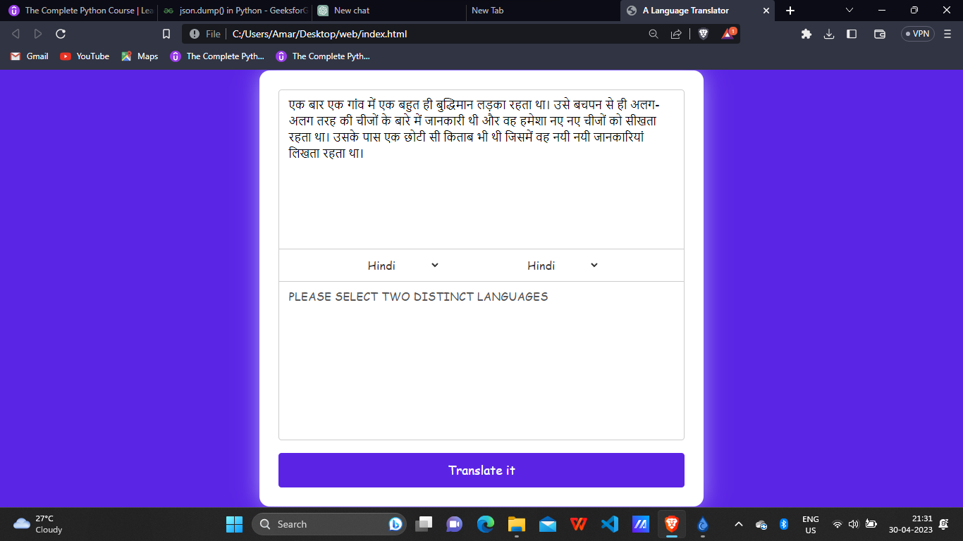

4.BENGALI TO HINDI

